INTERCOMPANY SALES

* INTERCOMPANY SALES OCCURS WHEN THE SALES ORGANIZATION BELONGS TO A DIFFERENT COMPANY CODE THAN THE DELIVERING PLANT.
* STEPS:

1. CREATE TWO COMPANY CODES (A003) AND (AZBY) UNDER A COMPANY
2. CREATE AND ASSIGN SALES AREA INDIVIDUALLY TO A COMPANY CODE
3. CREATE AND ASSIGN PLANT INDIVIDUALLY TO A COMPANY CODE AND SALES ORG
4. CREATE A MATERIAL IN ONE PLANT AND EXTEND IT TO ANOTHER PLANT
5. LINK SALES AREA OF FIRST COMPANY CODE TO THE PLANT OF THE SECOND CMPY CODE WHICH SALES THE MATERIAL

* HERE,COMPANY IS A003
* FIRST COMPANY CODE IS A003
* SALES ORG (A003), DIST CHNL (A3),DIV (A3)
* PLANT IS A003
* SECOND COMPANY CODE IS AZBY
* SALES ORG(AZ),DIST CHNL(AZ),DIV(AZ)
* PLANT IS AZBY
* ASSIGN SALES ORG AND DIST CHNL OF FIRST COMPANY CODE (A003, A3, A3 ) TO PLANT AZBY OF SECOND COMPANY CODE.

1. CREATE AN INTERNAL CUSTOMER FOR SALES AREA A003 USING SALES AREA AZBY
2. ASSIGN THE CUSTOMER NO GENERATED TO SALES ORG A003 AS INTERNAL CUSTOMER, SO THAT SALES ORG A003 IS REPRESENTED AS AN INTERNAL CUSTOMER TO SALES AREA AZBY.

PATH: SALES AND DISTRIBUTION – BILLING – INTERCOMPANY BILLING –DEFINE INTERNAL CUSTOMER NO BY SALES ORG

1. MAINTAIN PRICE CONDITION PI01 FOR INTERCOMPANY PRICING
2. PRICE CONDITION PR00 FOR CUSTOMER PRICING
3. TRANSACTION:

SALES ORDER

DELIVERY

CUSTOMER INVOICE SEND FROM SALES ORG (A003) TO END CUSTOMER

INTERCMPY INVOICE SEND FROM SALES ORG (AZBY) TO SALES ORG (A003)

* CONFIGURATION:
* CREATE TWO COMPANY CODES
* PATH: ENTERPRISE STRUCTURE – DEFINITION – FINANCIAL ACCOUNTING – COMPANY CODE
* CREATED TWO COMPANY CODES AND ASSIGNED BOTH COMPANY CODES TO COMPANY
* PATH: ENTERPRISE STRUCTURE – ASSIGNMENT – FINANCIAL ACCOUNTING – ASSIGN COMPANY CODE TO COMPANY
* CREATE TWO SALES AREA
* PATH FOR SALES ORG AND DIST CHANNEL
* ENTERPRISE STRUCTURE – DEFINITION – SALES AND DISTRIBUTION –SALES ORG AND DISTRIBUTION CHANNEL
* PATH FOR PLANT AND DIVISION:
* ENTERPRISE STRUCTURE – DEFINITION – LOGISTICS GENERAL
* CREATED SALES ORG A003 AND AZBY,CREATED DISTRIBUTION CHANNEL AND
* CREATED PLANT AND ,DIVISION AND
* ASSIGN TWO CREATED SALES AREA TO COMPANY CODE
* PATH: ENTERPRISE STRUCTURE – ASSIGNMENT – SALES AND DISTRIBUTION – ASSIGN SALES ORGANIZATION TO CMY CODE
* ASSIGN DISTRIBUTION CHANNEL TO SALES ORG AND ASSIGN DIVISION TO SALES ORG
* ASSIGN PLANT TO COMPANY CODE.PATH: ENTERPRISE STRUCTURE – ASSIGNMENT – LOGISTICS GENERAL—ASSIGN PLANT TO CMY CODE
* SET UP SALES AREA.PATH: ENTERPRISE STRUCTURE – ASSIGNMENT – SALES AND DISTRIBUTION – SET UP SALES AREA
* ASSIGN SALES ORG TO PLANT.PATH: ENTERPRISE STRUCTURE – ASSIGNMENT – SALES AND DISTRIBUTION – SALES ORG--DIST CHNL—PLANT
* A MATERIAL 33 WAS PREVIOUSLY CREATED FOR PLANT A003 SO,EXTENDING IT TO ANOTHER PLANT AZBY IN T.CODE MM01

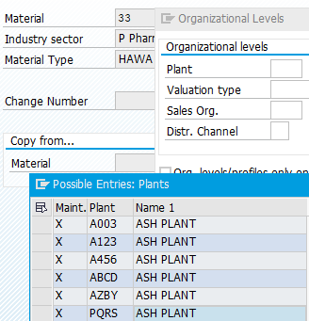

* INTERNAL CUSTOMER ASSIGNEMENT PATH:

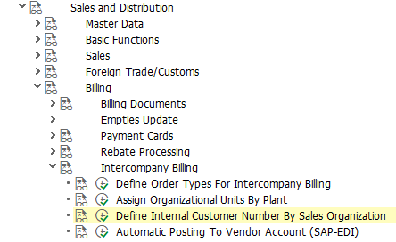

* CREATED AN INTERNAL CUSTOMER 100363 AND ASSIGNED TO A003

SALES ORG

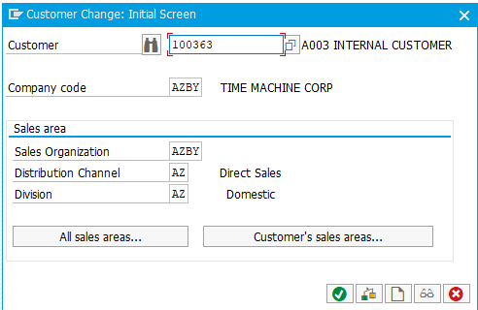

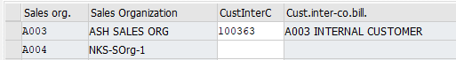

MAINTAINED CONDITION RECORDS FOR COND TYPE ZPR0 AND PI01

ZPR0:CUSTOMER PRICE-- 50.00 INR

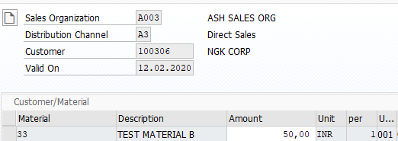

PI01:INTERCOMPANY PRICE 35.00 INR

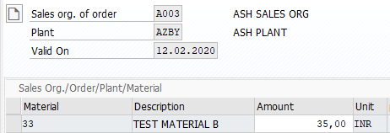

CREATED A PRICING PROCEDURE WITH PI01:

MAINTAINED REQUIREMENT 22 FOR INTERCOMPANY PRICE PI01 AS IT SHOULD BE ACTIVATED IN INTERCMPY BILLING.

WHILE NORMAL PRICING COND TYPE ZPR0 HAS REQUIREMENT 2 ITEM WITH PRICING

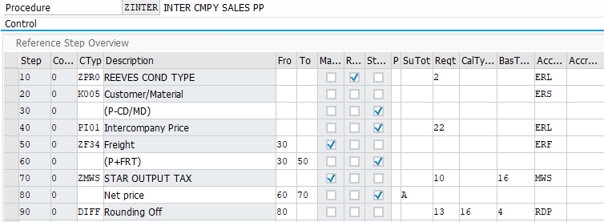

CHECK IF THE OUR ORDER TYPE ASSIGNED FOR INTERCOMPANY BILLING

PATH:

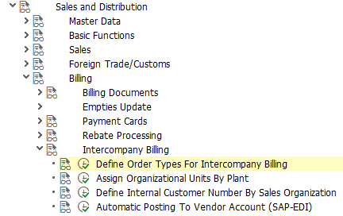



CHECK FOR COPY CONTROLS FROM DELIVERY TO BILLING DOC’S WHETHER INTERCOMPANY SETTING HAS BEEN ACTIVATED:

T.CODE: VTFL

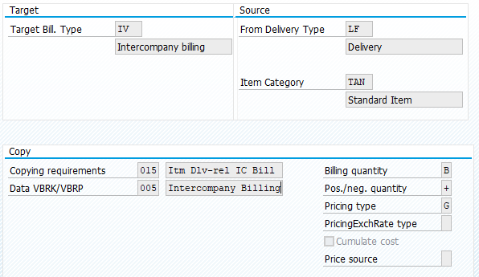

CREATE TRANSACTION:

CREATED ORDER 15874 WITH PLANT AZBY SINCE WE DO NOT HAVE STOCK IN OUR PLANT A003 WE ARE PROCURING FROM PLANT AZBY AND DELIVERING TO THE END CUSTOMER 100306

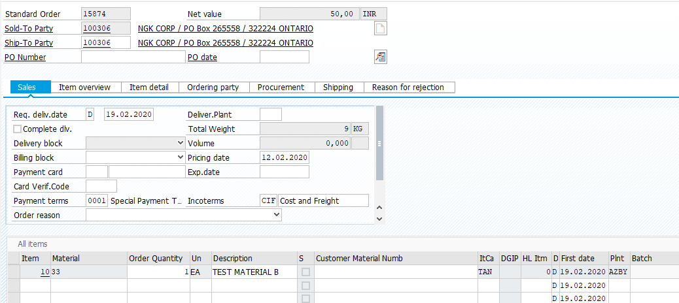

IN SALES ORDER PRICING PI01 (INTERCMPY PRIC) VALUE 35.00 INR WILL NOT BE TAKEN INTO NET VALUE CALCULATION

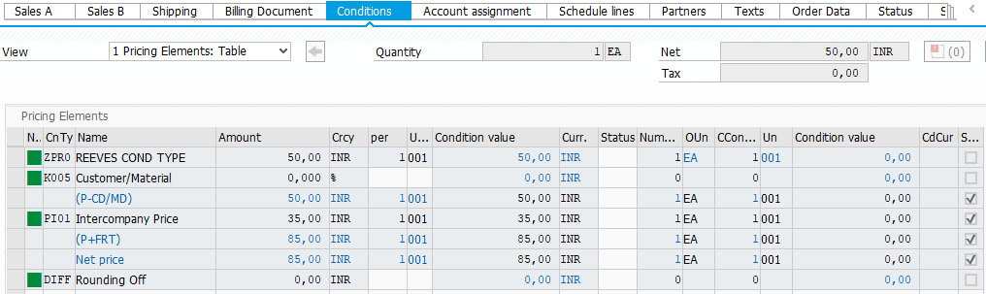

NEXT CREATED DELIVERY USING PLANT AZBY AND S.LOC AZBY SINCE WE ARE PICKING THE MATERIAL FROM ANOTHER COMPANY CODE AZBY AND THEN DELIVER IT TO THE CUSTOMER AS WE DO NOT HAVE STOCK IN OUR PLANT A003

CREATED DELIVERY: 80017942

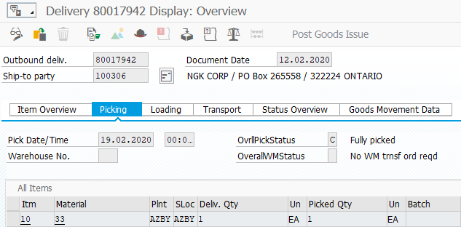

CREATED END CUSTOMER INVOICE: 90039618

IN THIS INVOICE, NORMAL PRICE CAN BE SEEN BUT YOU CANNOT SEE THE INTERCOMPANY PRICE

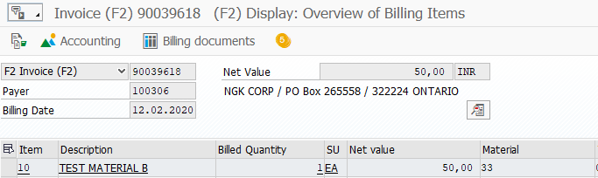

IN BILLING WE CAN SEE THE SALES AREA A003 AND PRICING PROCEDURE ZINTER UNDER HEADER TAB

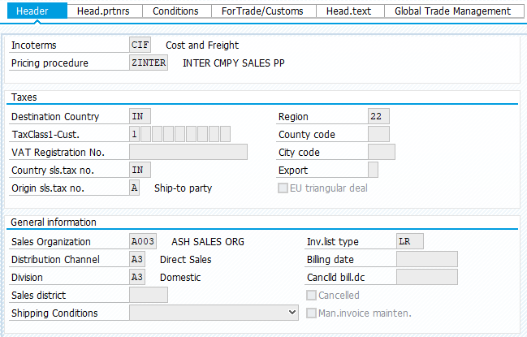

THEN CREATE INTERCOMPANY INVOICE USING T.CODE VF01 USING THE SAME DELIVERY DOC NO

CREATED INTERCMPY INVOICE: 90039619

HERE, WE CAN SEE ONLY THE INTERCOMPANY PRICING WHICH IS 35.00 INR MAINTAINED IN CONDITION RECORDS VK11 UNDER COND TYPE PI01.AS INTERCOMPANY COND TYPE BECOMES ACTIVE AND NORMAL PRICING COND ZPR0 BECOME INACTIVE.

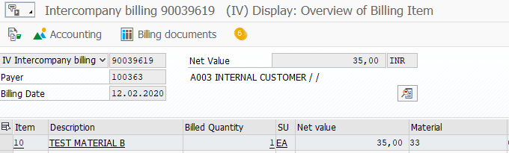

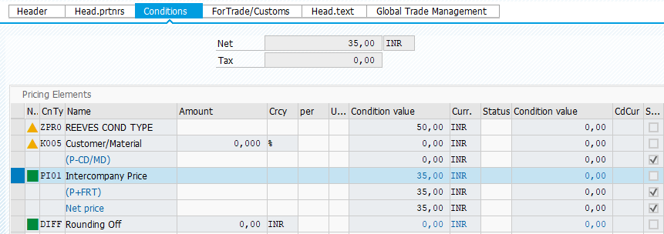

HERE, THE SALES AREA IS AZBY CAN BE SEEN UNDER HEADER TAB

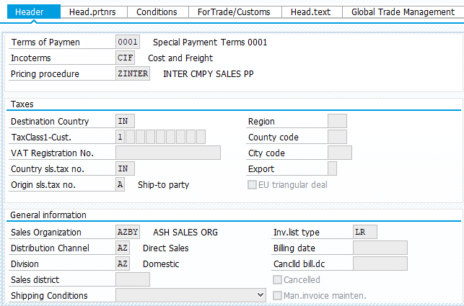

SALES DOCUMENT FLOW CAN BE CHECKD IN VA02

